**QIS Assignment part 1 (d.) : Understanding the count of bikes rented in relation to the various environmental conditions**

**Submitted by Jophy Joseph Sep 11,2022**

1. Response against **atemp** (Normalized feeling temperature in Celsius)

**Conclusion:**

**count of rentals are maximum when the normalized feeling temperature is around 0.5**

1. Response against season (1:spring, 2:summer, 3:fall, 4:winter)

**Conclusion:**

**count of rentals are slightly more in the spring season**

3. **weathersit** :

- 1: Clear, Few clouds, Partly cloudy, Partly cloudy

- 2: Mist + Cloudy, Mist + Broken clouds, Mist + Few clouds, Mist

- 3: Light Snow, Light Rain + Thunderstorm + Scattered clouds, Light Rain + Scattered clouds

- 4: Heavy Rain + Ice Pallets + Thunderstorm + Mist, Snow + Fog

**Conclusion:**

**When weather situation is (1.) …much more rentals**

4. **temp :** Normalized temperature in Celsius. The values are divided to 41 (max)

**Conclusion:**

**More rentals when 0.22 <temp < 0.76**

5. **atemp**

**Conclusion:**

**More rentals when 0.22 <temp < 0.76**

6. **hum** : Normalized humidity. The values are divided to 100 (max)

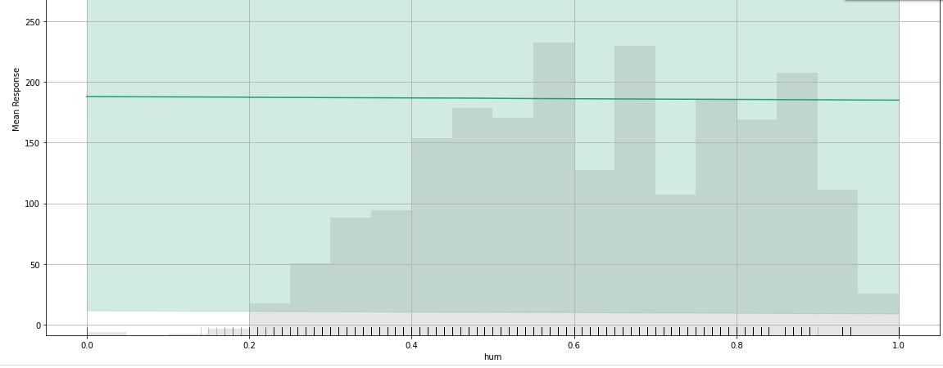

**Conclusion:**

**More rentals when 0.26 < hum < 0.95**

7. windspeed : Normalized wind speed. The values are divided to 67 (max)

**Conclusion:**

**More rentals when thw windspeed is less. There seems to be no cycles rented when the windspeed is above 0.45.**